**3-4 : Data Modeling Terminology and Mapping Practices**

**Exercise 1: Identify entities, attributes, instances and their corresponding tables, rows and columns**

1. A
2. F
3. C
4. E
5. D
6. B
7. g

2. A. primary key

B. foreign key

C. unique key

D. mandatory

E. optional

3. A. ATR

B. PLR

C. CTR

4. 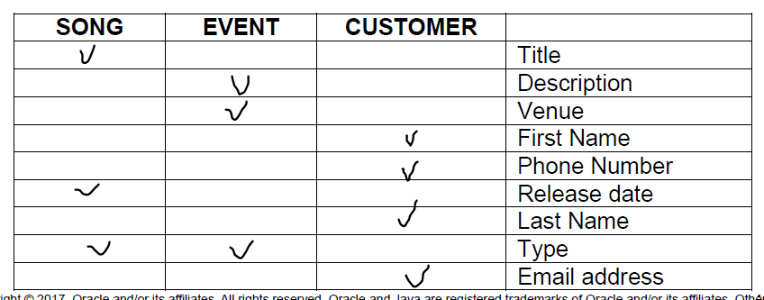

**Exercise 2: Mapping the Academic Database**

ENTITIES:

PARENT INFO, STUDENT, STUDENT COURSE DETAIL, COURSE, DEPARTMENT, FACULTY, ONLINE, SEATED, STUDENT ATTENDANCE, ACADEMIC SESSION, EXAM RESULT, EXAM, FACULTY COURSE DETAIL

ATTRIBUTES:

In Parent Information entity:

# ID -- pk

* parent 1 FN -- mandatory

* parent 1 LN -- mandatory

* parent 2 FN -- mandatory

* parent 2 LN -- mandatory

#student Id -- foreign key for the entity Student where attributes are:

# ID -- pk

*First Name -- mandatory

*Last Name -- mandatory

*Registration Year -- mandatory

*Email -- mandatory, uk

#grade -- foreign key for the Student Course Detail where one attribute

*Grade -- mandatory and 2 foreign keys: student id and course id what are make relationships

with two entities: Student and Course.